**Thasneema updated the User and Admin dashboards, and I (Ali) collaborated by testing the live UI pages and capturing screenshots.**

1. [adminDashboard.jsp](https://github.com/thasneemsha/QFit-Fitness-Tracker/blob/feature/thasneem-frontend-ui-ux/src/main/webapp/adminDashboard.jsp)

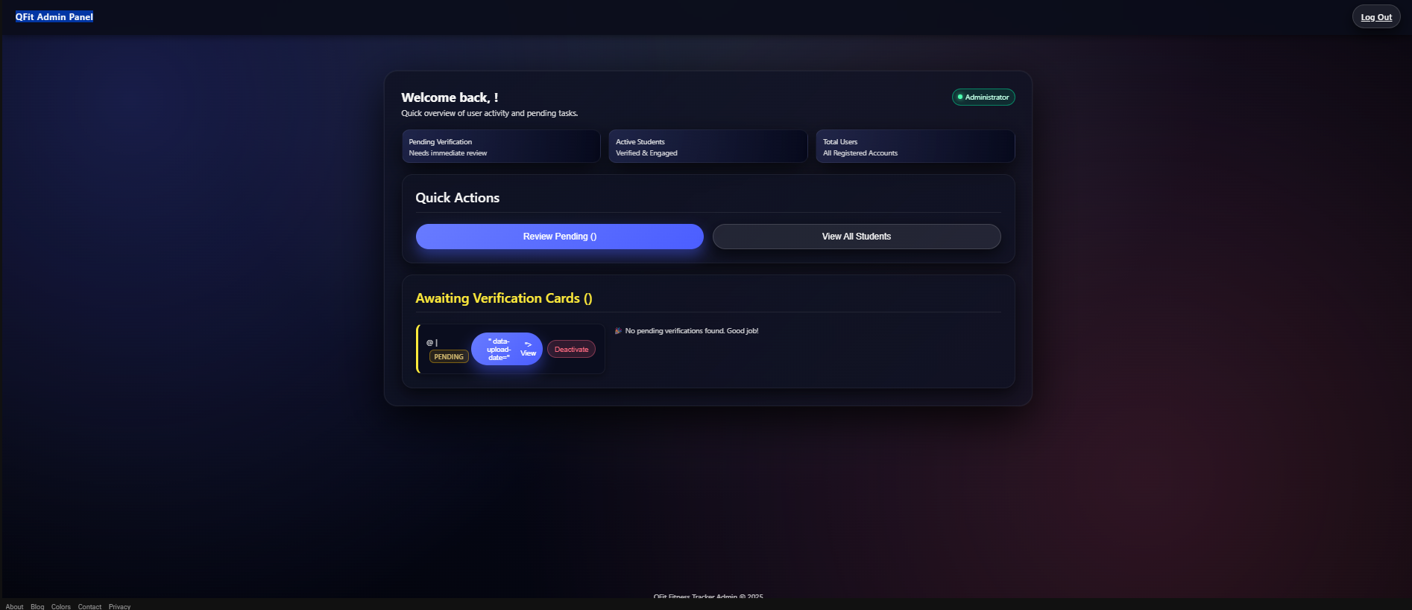

1. editPlan.jsp

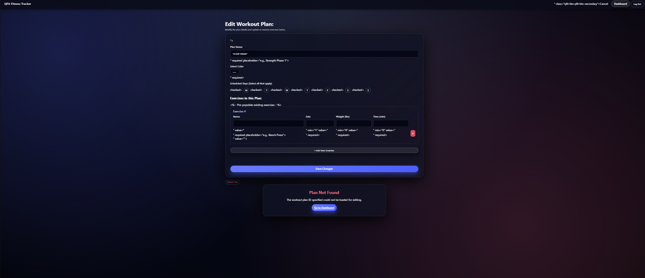

1. [error.jsp](https://github.com/thasneemsha/QFit-Fitness-Tracker/blob/feature/thasneem-frontend-ui-ux/src/main/webapp/error.jsp)

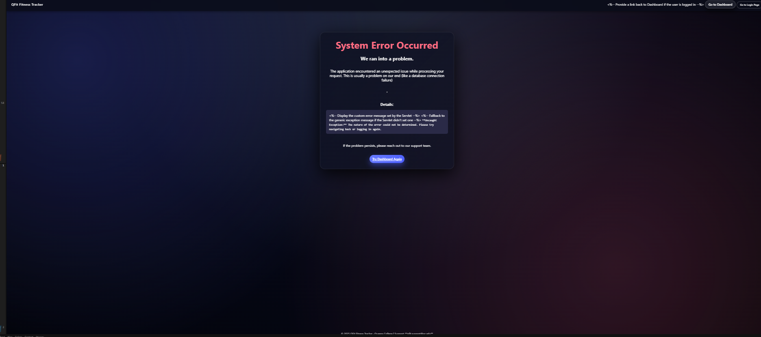

1. [Index.jsp](https://github.com/thasneemsha/QFit-Fitness-Tracker/blob/feature/thasneem-frontend-ui-ux/src/main/webapp/index.jsp)

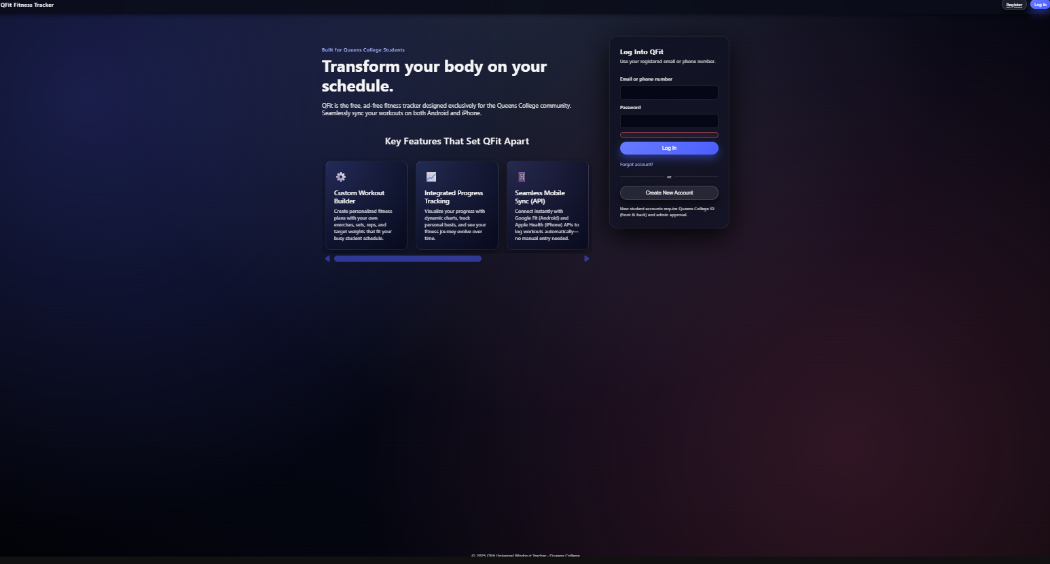

1. [logWorkout.jsp](https://github.com/thasneemsha/QFit-Fitness-Tracker/blob/feature/thasneem-frontend-ui-ux/src/main/webapp/logWorkout.jsp)

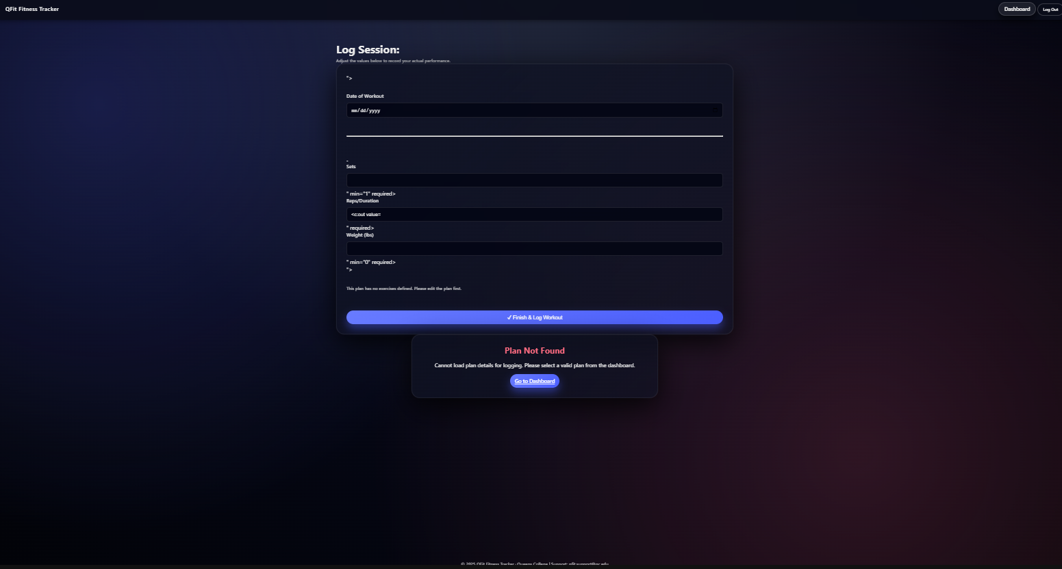

1. [pendingAproval.jsp](https://github.com/thasneemsha/QFit-Fitness-Tracker/blob/feature/thasneem-frontend-ui-ux/src/main/webapp/pendingAproval.jsp)

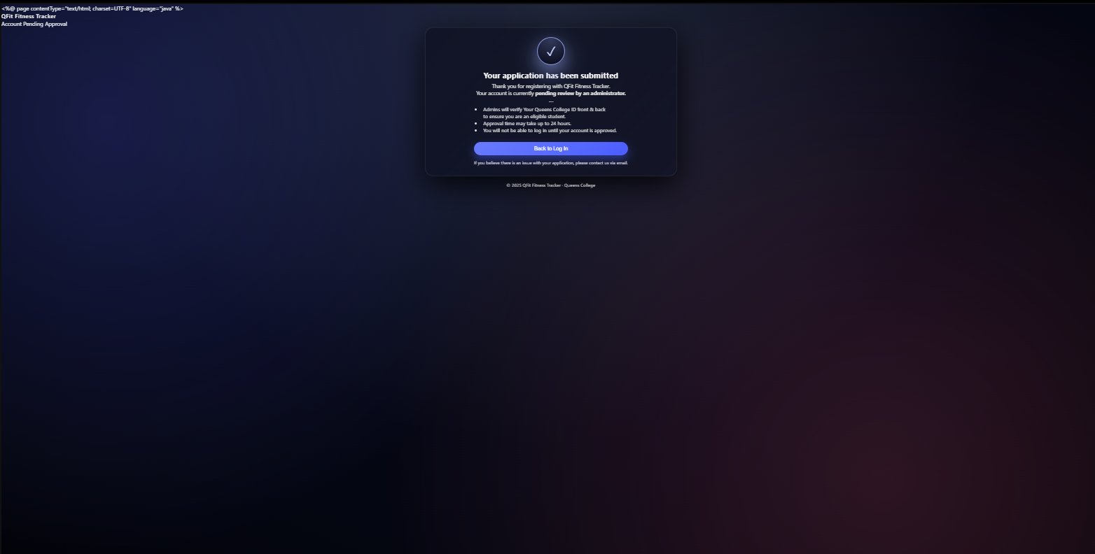

1. [planDetails.jsp](https://github.com/thasneemsha/QFit-Fitness-Tracker/blob/feature/thasneem-frontend-ui-ux/src/main/webapp/planDetails.jsp)

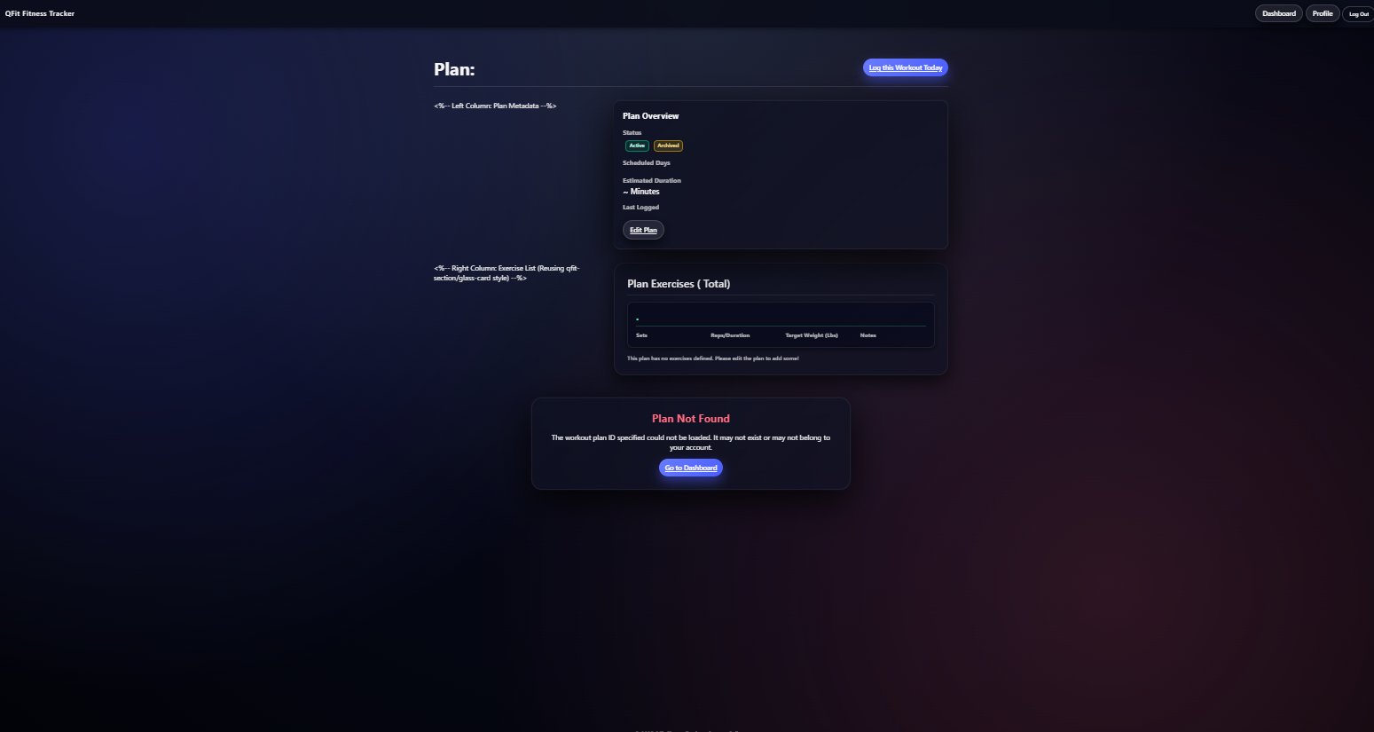

1. [profile.jsp](https://github.com/thasneemsha/QFit-Fitness-Tracker/blob/feature/thasneem-frontend-ui-ux/src/main/webapp/profile.jsp)

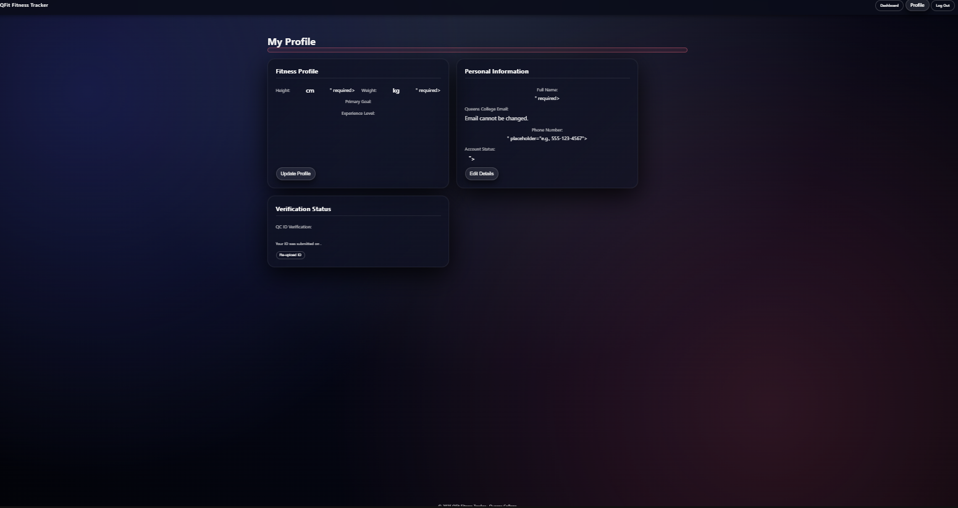

1. [register.jsp](https://github.com/thasneemsha/QFit-Fitness-Tracker/blob/feature/thasneem-frontend-ui-ux/src/main/webapp/register.jsp)

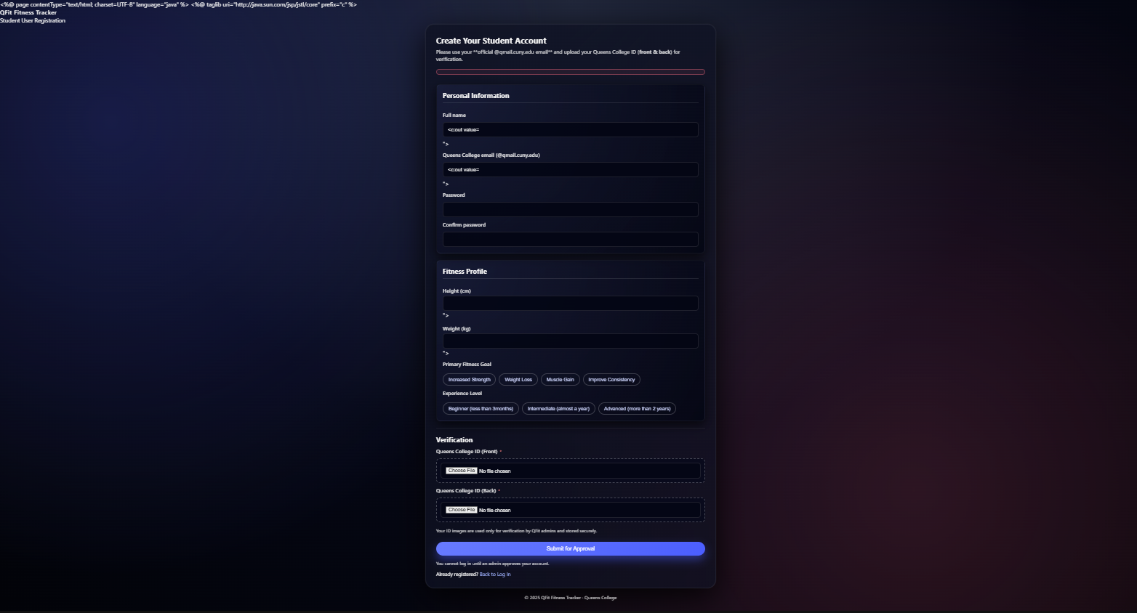

1. [userDashboard.jsp](https://github.com/thasneemsha/QFit-Fitness-Tracker/blob/feature/thasneem-frontend-ui-ux/src/main/webapp/userDashboard.jsp)

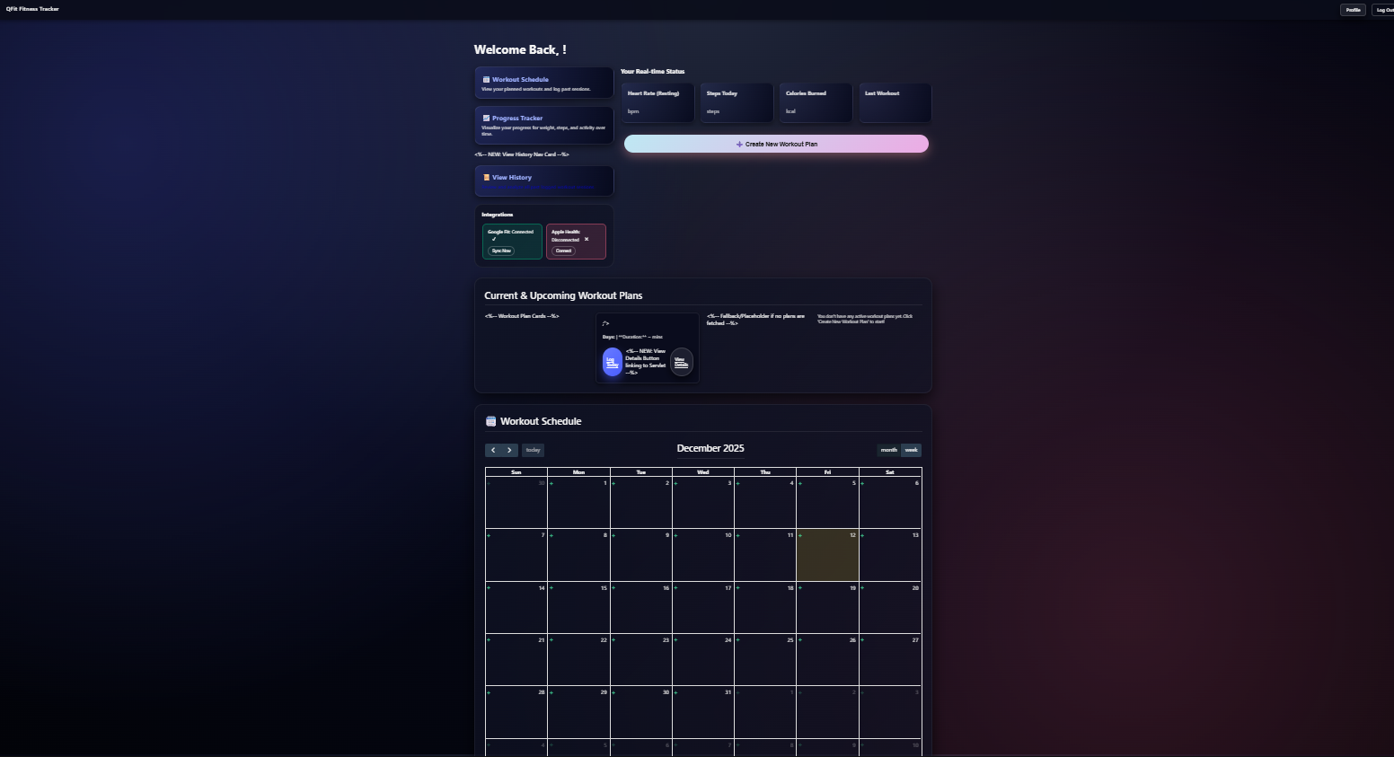

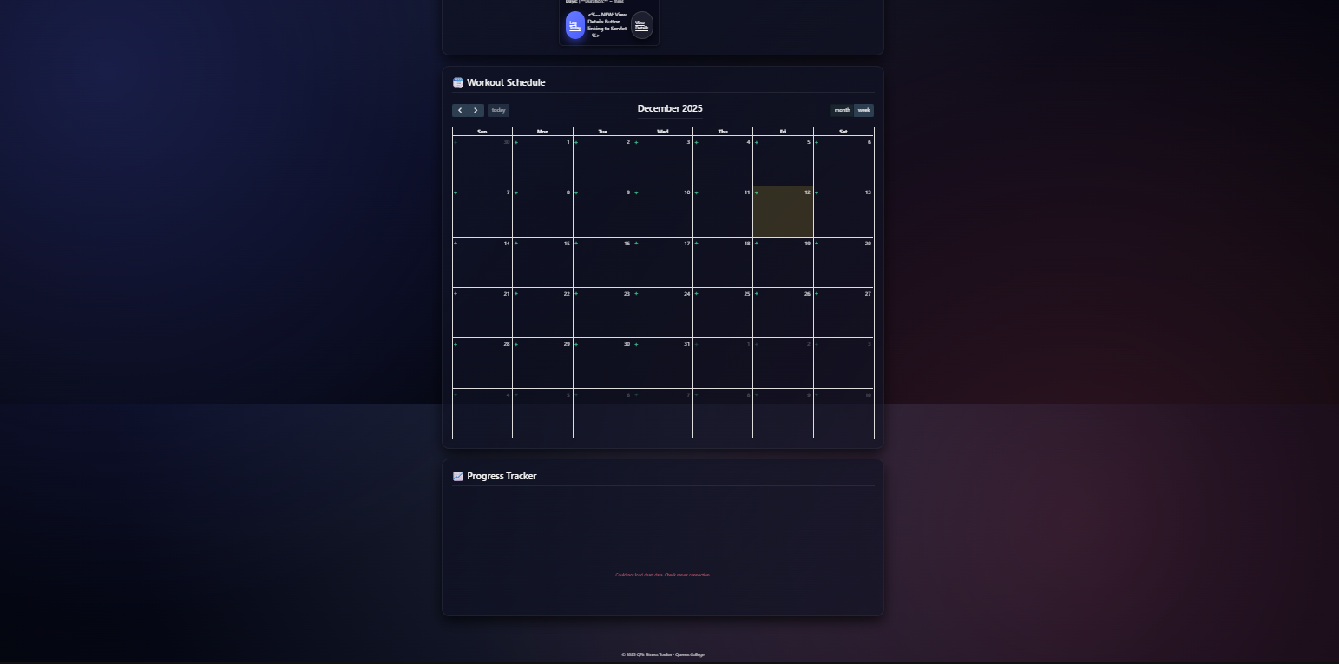

1. [viewSession.jsp](https://github.com/thasneemsha/QFit-Fitness-Tracker/blob/feature/thasneem-frontend-ui-ux/src/main/webapp/viewSession.jsp)

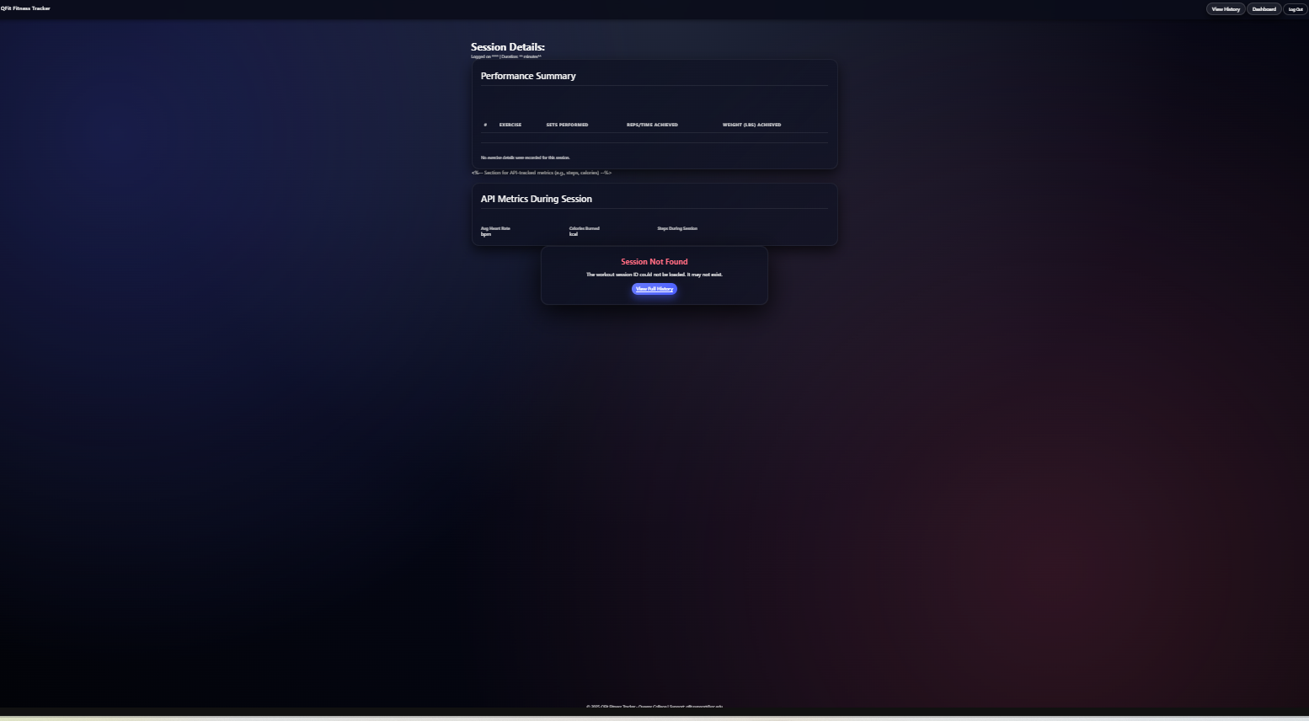

1. [workoutHistory.jsp](https://github.com/thasneemsha/QFit-Fitness-Tracker/blob/feature/thasneem-frontend-ui-ux/src/main/webapp/workoutHistory.jsp)

